Chapter 8 Multiprocessors

8.1 Characteristics of multiprocessors
Core concept
- A multiprocessor is a single computer system that contains two or more independent processing units (CPUs or IOPs) interconnected with memory and I/O equipment.
- These processors work under the control of a single, unified operating system to solve a problem.
- Key classification: They are classified as MIMD (Multiple Instruction Stream, Multiple Data Stream) systems,
  - meaning, each processor can execute a different instruction stream of a different data stream simultaneously

Characteristics:
- Multiple Processors: Two or more CPUs (or IOPs) reside within a single computer system
- Shared Memory & I/O: All processors share access to the main memory, I/O devices and the operating system. This creates a tightly-coupled system.
- Single OS Control: The entire system is managed by one operating system, which enables interaction and cooperation between all processors and system components.
- Improved Performance: Allows for the execution of multiple independent jobs in parallel or the splitting of a single job into parallel tasks
- enhanced reliability: If one processor fails, the system can often continue to operate at a reduced capacity, a property known as graceful degradation

Boosting Performance/Reliability
How performance is increased:
- Job Parallelism: Run multiple independent applications (e.g., a web browser and a video renderer) simultaneously on different processors.
- Task Parallelism: Decompose a single, large program (e.g., a scientific simulation) into smaller subtasks that can be executed in parallel across multiple processors, significantly speeding up the solution
- Methods: this can be done by the programmer explicitly defining parallel tasks, or by a smart compiler that automatically detects and exploits parallelism in the code
How Reliability is increased:
- Graceful Degradation:
  - The system is inherently more reliable because the failure of single processor does not cause a total system crash
  - The remaining processors can take over the workload
    - allowing the system to continue functioning, albeit more slowly
  - key feature for critical systems

Multi: processor vs computer vs processing
- Multiprocessor (Tightly Coupled):
  - concept: a single system with multiple processors sharing a common central memory
  - communication: processors communicate by reading from and writing to shared memory.
  - very fast
- Multicomputer (Loosely Coupled):
  - concept: a network of independent, complete computers, each with its own private memory
  - Communication: Processors communicate by passing explicit messages over a network like LAN
  - is slower than shared memory
- Multiprocessing (The action)
  - the process or capability of a system to execute code on more than one processor.
  - a multiprocessor system performs multiprcoessing

Classification by Memory Organisation
- Shared Memory Multiprocessor
  - Concept: all processors share a single, unified address space. any processor can read/write to any memory location
  - analogy: a shared whiteboard in a meeting room, everyone can see and write on the same board
  - adv: fast and simple communication between processors (just write to memory)
  - disadv: memory access can be a bottleneck if many processors try to access it simultaneously, aka memory contention
  - use case: ideal for tasks that require a high degree of interaction and data sharing between parallel tasks
- Distributed Memory Multiprocessor
  - concept: each processor has its own private local memory. no global, shared memory
  - analogy: each person in a class, has their own notebook. to share information, they must explicitly send a message
  - adv: avoids memory contention, scales more easily to a a large number of processors
  - disadv: communication between processors is slower and more complex as it requires message passing
  - use case: most efficient for problems that can be split into tasks with minimal interaction

8.2 Interconnection Structures
- the components that form a multiprocessor system are CPUs, IOPs connected to input-output devices and a memory unit
- the interconnection structure is the nervous system that allows processors, memory and I/O to communicate
- the interconnection between the components can have different physical configurations, depending on the number of transfer paths that are available.
  - between the processors and memory in a shared memory system
  - among the processing elements in a loosely coupled system
- there are various physical forms available for establishing an interconnection network
  - timeshared common bus
  - multiport memory
  - crossbar switch
  - multistage switching network
  - hypercube system

Time Shared Common Bus
- concept:
  - simplest structure
  - all components (CPUs, Memory, IOPs) are connected to a single, common set of wires (the bus).
- analogy: a single-lane road that everyone must use. one car can use the road at a time
- working:
  - a processor wanting to communicate must first check if the bus is free
  - it then places the address and data on the bus
  - only one such transfer can occur at any given time
- adv: simple low cost, easy to expand
- disadv:
  - major bottleneck as single path limits the total system bandwidth,
  - single point of failure as if the bus fails, the entire system fails
  - low rate of communication as only one component can communicate with other component
- evolution: to reduce bottleneck, a dual-bus structure can be used, where each processor has a local bus and connects to the system bus, via a bridge
  - this reduces traffic on the main bus
- single bus system figure:
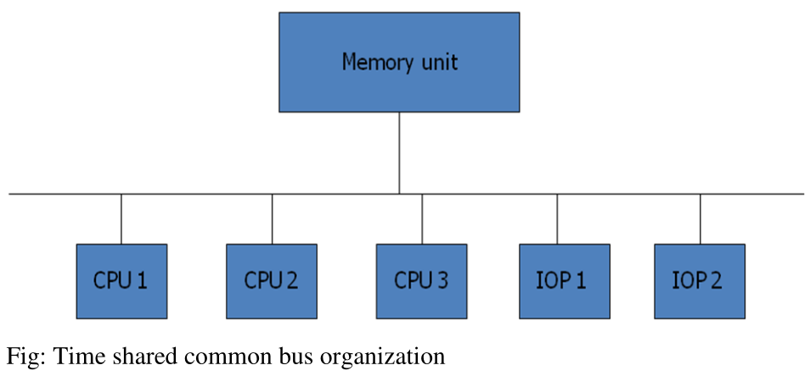
- a more economical implementation of a dual bus structure is depicted in the figure below:
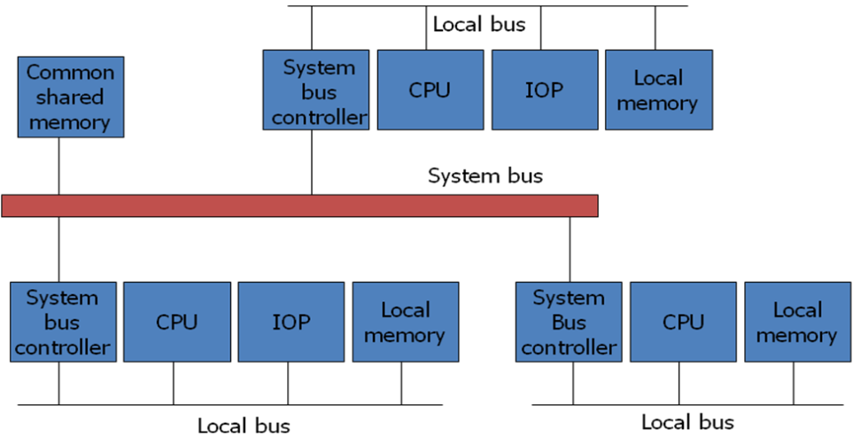

Multiport Memory
- concept: a dedicated path is established between each processor and each memory module
  - the memory controller has multiple ports
- analogy: a switchboard with a direct, dedicated line to every office
- working:
  - the memory module itself has internal control logic
  - if two processors request the same memory module simultaneously, the controller arbitrates (e.g., using fixed priorities) to grant one access.
- adv: very high potential bandwidth due to multiple simultaneous paths
- disadv:
  - extremely complex and expensive memory controller
  - physically bulky due to the large number of cables and connections
  - difficult to scale; adding a new processor requires adding a port to every memory module
- Figure for the memory organisation:
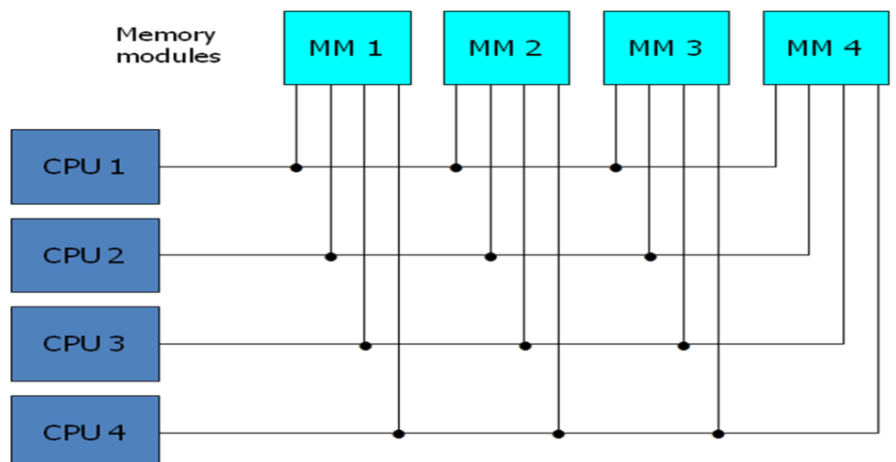

Crossbar Switch
- concept: a grid of switches that creates a dedicated, non-blocking path between any processor and any memory module
- analogy: a full telephone switchboard where any incoming line can be connected to any outgoing line without blocking others (as long as the destination is free).
- working:
  - at every intersection of a processor bus and a memory path, there is a crosspoint switch
  - when a processor wants to access a memory module, the corresponding crosspoint switch is closed, establishing a direct connection
  - key feature: it supports simultaneous transfers from all processors to all memory modules as long as each memory module is accessed by only one processor at a time.
- adv: very high bandwidth, non-blocking for distinct memory modules.
- disadv: the number of crosspoints scales as m x n, making it complex and expensive for large systems (e.g., 64x64 requires 4096 switches)
- Figure for the functional design switch:
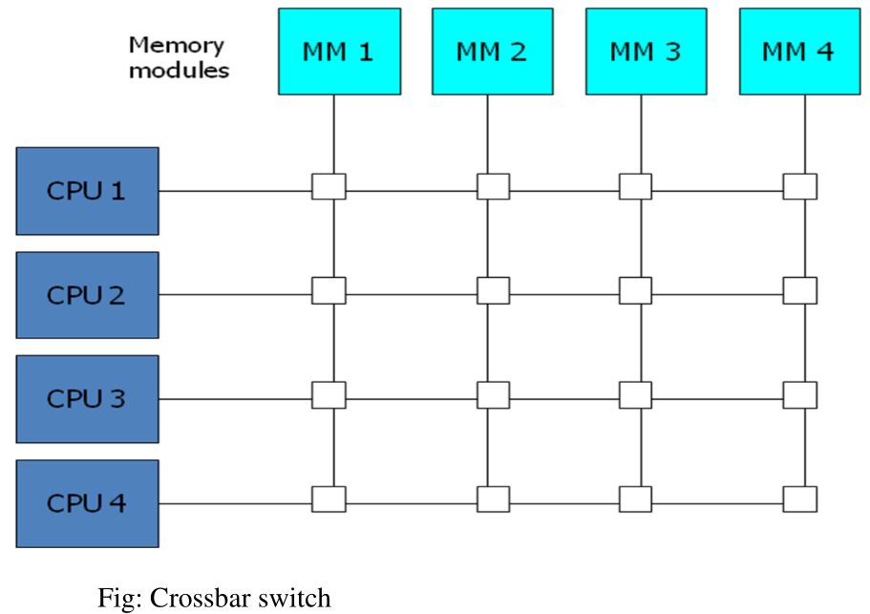
  - the small square in each crosspoint is a switch that determines that path from a processor to a memory module
- Block Diagram for the crossbar switch:
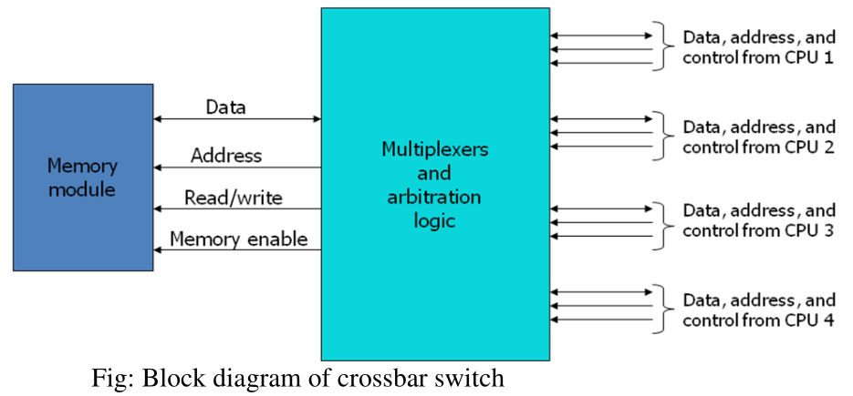

Multistage Switching Network
- concept:
  - a compromise between the simple bus and the complex crossbar.
  - it uses multiple stages of small (e.g., 2x2) interchange switches to connect many inputs to many outputs
- analogy: a multi-level road interchange with on and off-ramps, which is more complex than a single road, but cheaper than direct road between every origin and destination
- working:
  - building block: a 2x2 interchange switch that can route its two inputs to its two outputs
  - these small switches are arranged in multiple stages (e.g, Omega Network).
  - the path is set up by configuring each stage switch based on bits of the destination address.
- adv: more scalable and lower cost than a full crossbar for a large number of processors
- disadv:
  - blocking network: unlike the crossbar, certain communication patterns can cause conflicts (blocking) even if the source and dstination are free, because an intermediate switch might be busy
  - adds some latency due to the multiple stages a message must pass through
- in a tightly coupled multiprocessor system, the processor and the destination is a memory module
- Set up the path -> transfer the address into memory -> transfer the data
- in a loosely coupled multiprocessor system, both the source and destination are processing elements.
- concept of the switch is shown below:
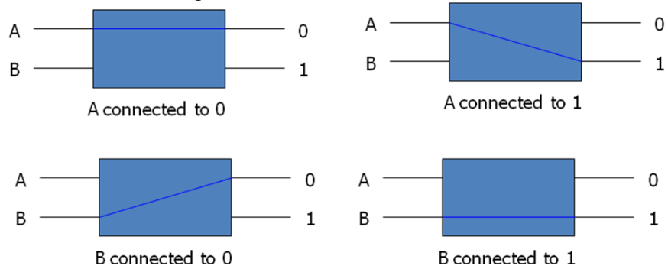
- Using the 2x2 switch as a building block, it is possible to build a multistage network to control the communication between a number of sources and destinations
  - to see how this is done, consider the binary tree in the figure:
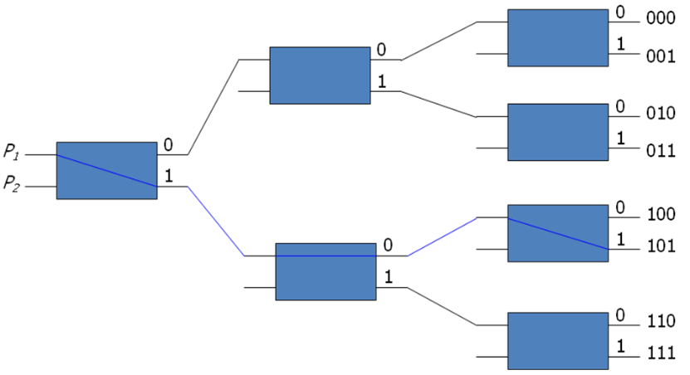
  - certain request patterns cannot be satisfied simultaneously. i.e. if P1 -> 000 ~ 011, then P2 -> 100 ~ 111
  - One such topology is the omega switching network, shown below:
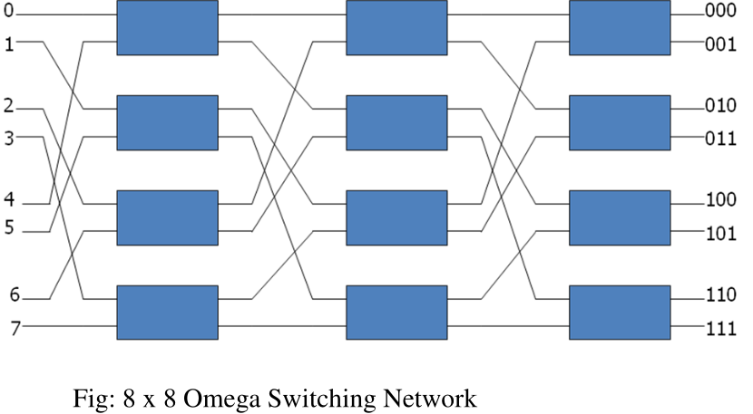
  - certain request patterns cannot be connected simultaneously i.e. any two sources cannot be connected simultaneously to destination 000 and 0001

Hypercube System
- concept:
  - a topology for distributed-memory (loosely-coupled) systems
  - processors are arranged in an n-dimensional cube
  - each processor is directly connected to its n neighbours
- working:
  - system has N = 2 processors
  - each processor is assigned a unique n-bit binary address
  - a direct connection exists between processors if their binary addresses differ by exactly one bit
  - example: in a 3-cube, processor 000 (0) is connected to 001 (1), 010 (2) and 100 (4)
- example:
  - n = 1: 2 processors (0 and 1), connected by a line
  - n = 2: 4 processors (00, 01, 10, 11) arranged in a square.
    - each corner is connected to 2 others
  - n = 3: 8 processors arranged in a cube
    - each corner is connected to three others
- Routing: to send a message from a source to a destination:
  - compute the exclusive-OR (XOR) of the source and destination address
  - the result is a bit mask indicating which bits differ
  - the message is routed through any one of the dimensions where the bits differ, moving one dimension at a time until it reaches the destination.
  - the maximum distance possible is n hops
- adv: low latency for local communication, highly scalable, no single point of failure
- disadv: the number of ports per processor grows with n, which can be physically limiting
- figure below shows the hypercube structure for n=1,2,3:
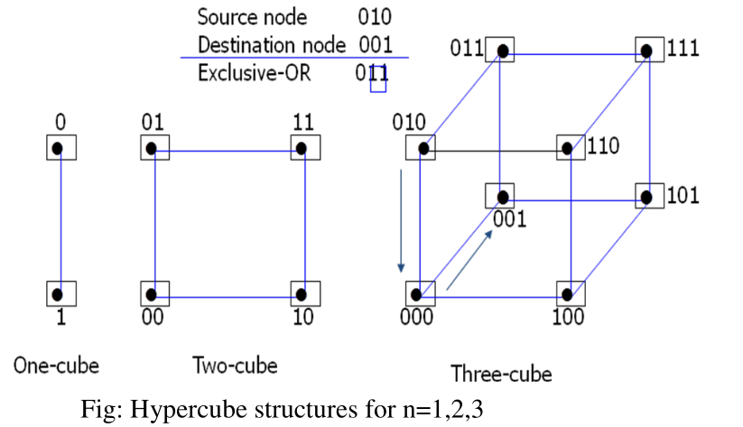
- a representative of the hypercube architecture is the Intel iPSC computer complex
  - it consists of 128 (n=7) microcomputers, each node consists of a CPU, a floating-point processor, local memory and serial communication interface units.

Comparision
Features | TSB | CS | MS | HC
Coupling | Tightly | Tightly | Tightly | Loosely
Performance | Low | very high | medium-high | high
Scalability | Poor | poor | good | excellent
Cost | Low | very high | medium | medium-high
Complexity | Low | high | medium | medium
Key Trait | Single shared path | dedicated, non-blocking paths | multi-stage, may block | direct links to neighbors
Best For | Small, low-cost system | demanding, medium-sized systems | larger shared-memory systems | large-scale distributed computing

8.3 Interprocessor Communication and Synchronisation
- communication is how processors share data and updates
- synchronisation is how they coordinate their actions to avoid messing up shared data and updates

Interprocess Communication
- mechanism that allows processors to exchange data and signals

Shared Memory Communication (Tightly-Coupled Systems)
- concept:
  - processors communicate by reading from and writing to a common, shared location.
  - most common method in tightly-coupled systems
- mechanism: the "Mailbox"
  - A sending processor writes a message (data, request, status) into a designated memory block, called a 'mailbox'.
  - the receiving processor periodically checks the mailbox for new messages
- disadvantage: this polling method can be slow and inefficient, as the receiver wastes time checking for messages that may not be there
- improvement: interrupt-driven method
  - the sending processor, after placing the message in the mailbox, sends an interrupt signal directly to the receiver processor.
  - the receiver doesn't have to constantly check and, it can attend to the message immediately
  - communication is much faster

Message Passing Communication (Loosely-Coupled Systems)
- concept: in systems with no shared memory, processors communicate by sending discrete messages (packets) over an interconnection network, similar to how computers talk on LAN
- mechanism: one processor explicitly calls a procedure or sends a message to another processor's memory via I/O channels
- performance factors: the efficiency depends on
  - network topology
  - data link speed
  - the communication routing protocol

Interprocessor Synchronisation
- synchronisation is a special form of communication where the data being exchanged is control information.
- used to ensure the correct order of operations and to protect shared resources

Need
- mutually exclusive access:
  - prevents two or more processors from accessing and modifying a shared, writable resource (like a memory variable or a file) at the same time.
  - Without it, data corruption is inevitable
- critical section:
  - a segment of code where a process accesses the shared resource.
  - the fundamental rule of synchronisation is that only one process can be in its critical section at any time.

Mechanism: Mutual Exclusion with Semaphore
- Concept:
  - semaphore is a protected variable (or an abstract data type) used to control access to a shared resource.
  - A binary semaphore (or mutex) is the most basic, with a value of 0 or 1.
- challenge:
  - the act of checking the semaphore's value and then locking it must be indivisible, i.e. an atomic operation
  - If not, two processors could both read the free signal and both proceed to lock it simultaneously.

Hardware Solution: The Test-and-Set Instruction
- concept:
  - the CPU provides a special hardware instruction that performs the "check-and-lock" operation in a single, uninterruptible memory cycle
- working:
  - the TSL SEM (Test and Set Lock) instruction does two things automatically:
    - reads the current value of the semaphore SEM into a register
    - sets the value of SEM to 1 (locked), regardless of what it read
- processor logic:
- Acquire_Lock:
TSL REGISTER, SEM # Atomically test and set the lock
CMP REGISTER, #0 # Was the lock FREE (0) when it checked?
JNE Acquire_Lock # If not, it was already locked, so loop and try again
RET # If yes, the lock is acquired; enter critical section

Release_Lock:
MOVE SEM, #0 # Set semaphore back to 0 (free)
RET # exit critical section
- the "Hardware Lock":
  - During the execution of the TSL instruction, the processor's "lock" signal is activated
  - it prevents any other processor or device from accessing memory bus until the instruction is complete
  - this enforces the atomicity

Operating System Configurations for Multiprocessors
the OS must manage shared resources and processors. 3 primary models:
Configuration | Description | Pros & Cons | Best For
Master-Slave | One processor, the master, is designated to run all OS kernel functions. Other processors (slaves) execute only user programs and make system calls to master | pros: simple to implement, avoids OS data structure contention.  cons: master can become a bottleneck. if the master fails, the entire system fails | asymmetric systems where processors are not identical
Separate OS | each processor has its own complete copy of the OS | pros: simple, no single point of failure for OS  cons: difficult to manage shared resources globally; no true-single system image. inefficient as each OS maintains its own tables | loosely-coupled systems (e.g., multicomputers)
Distributed (floating) OS | the OS routines are distributed among all processors. However, any specific OS function (e.g., memory manager) is performed only by one processor at a time, and this duty can "float" between processors | Pros: highly flexible and load-balanced; avoids a single master bottleneck; provides a true single-system image  cons: most complex to implement requires careful synchronisation of US data structures | Tightly-coupled multiprocessors (this is the model used in modern systems)

